Bobby Jindal

**From Wikipedia, the free encyclopedia**

https://en.wikipedia.org/wiki/Bobby%20Jindal  
Licensed under CC BY-SA 3.0:  
https://en.wikipedia.org/wiki/Wikipedia:Text_of_Creative_Commons_Attribution-ShareAlike_3.0_Unported_License

# Bobby Jindal

* *Jindal was re-elected in 2011 in a landslide, winning more than 65% of the vote.*
* *Piyush "Bobby" Jindal (born June 10, 1971) is an American politician who was the 55th Governor of Louisiana, between 2008 and 2016, and previously served as a Congressman and as the vice chair of the Republican Governors Association.*
* *On June 24, 2015, Jindal announced his candidacy for the Republican nomination in the 2016 presidential election.*

Piyush "Bobby" Jindal (born June 10, 1971) is an American politician who was the 55th Governor of Louisiana, between 2008 and 2016, and previously served as a Congressman and as the vice chair of the Republican Governors Association.

In 1996, Jindal was appointed secretary of the Louisiana Department of Health and Hospitals and in 1999, at age 28, he was appointed as the youngest president in the history of the University of Louisiana System. In 2001, President George W. Bush appointed Jindal as principal adviser to the U.S. Secretary of Health and Human Services.

He first ran for governor of Louisiana in 2003, but lost in the run-off election to Democratic candidate, Kathleen Blanco. In 2004, he was elected to the U.S. House of Representatives, becoming the second Indian American in Congress, and was re-elected in 2006. Jindal ran for governor again in the 2007 election and won, making him, at 36 years old, the second youngest governor of Louisiana after Huey P. Long, who was 35 when he was elected in 1928. Jindal was re-elected in 2011 in a landslide, winning more than 65% of the vote. He was the first Indian American governor, and the only one until South Carolina Governor Nikki Haley assumed office in 2011.

On June 24, 2015, Jindal announced his candidacy for the Republican nomination in the 2016 presidential election. He suspended his campaign in November 2015, subsequently announcing his support for Marco Rubio, who suspended his campaign on March 15, 2016. He finished his term as Governor in January 2016.

# Early life and education

* *He is the first of two sons of Raj (née Gupta) and Amar Jindal, from Punjab, India.*
* *Jindal attended Baton Rouge Magnet High School, graduating in 1988.*
* *Piyush Jindal was born on June 10, 1971 in Baton Rouge, Louisiana.*
* *At the time of their move to the U.S., Raj Jindal was to be a doctoral candidate in physics.*
* *Jindal was named to the 1992 USA Today All-USA Academic Team.*

Piyush Jindal was born on June 10, 1971 in Baton Rouge, Louisiana. He is the first of two sons of Raj (née Gupta) and Amar Jindal, from Punjab, India. His father is a civil engineer and graduate of Guru Nanak Dev University and Punjab University. His mother is a graduate of Rajasthan University and worked in nuclear physics at the Post Graduate Institute of Medical Education and Research in Chandigarh. Before immigrating to the United States, both his parents were lecturers at an Indian engineering college.

At the time of their move to the U.S., Raj Jindal was to be a doctoral candidate in physics. They left Malerkotla, Punjab in January 1971, six months before their son was born. Jindal's paternal grandfather was a merchant from Khanpur, Samrala and his maternal grandfather was a Ferozepur banker.

The family settled near Louisiana State University. Jindal attended Baton Rouge Magnet High School, graduating in 1988. While in high school, he competed in tennis tournaments, started various enterprises such as a computer newsletter, retail candy business, and a mail-order software company. He spent free time working in the stands at LSU football games.

Jindal graduated from Brown University in 1992 at the age of 20, with honors in two majors, biology and public policy.

Jindal was one of only 50 students nationwide admitted to the Program in Liberal Medical Education (PLME), guaranteeing him a place at Brown Medical School. He has been credited with leading Brown University's College Republicans student group.

Jindal was named to the 1992 USA Today All-USA Academic Team. He applied to and was accepted by both Harvard Medical School and Yale Law School, but studied as a Rhodes Scholar where he received an MLitt in political science with an emphasis in health policy from New College, Oxford in 1994. The subject of his thesis was "A needs-based approach to health care".

# Career

* *He then interned in the office of Rep. Jim McCrery of Louisiana, where McCrery assigned him to work on healthcare policy; Jindal spent two weeks studying Medicare to compile an extensive report on possible solutions to Medicare's financial problems, which he presented to McCrery.*
* *After completing his studies at Oxford, Jindal turned down an offer to study for a D.Phil.*
* *Instead, Jindal joined the consulting firm McKinsey & Company.*

After completing his studies at Oxford, Jindal turned down an offer to study for a D.Phil. in politics because his family couldn't afford to pay for his studies. Instead, Jindal joined the consulting firm McKinsey & Company. He then interned in the office of Rep. Jim McCrery of Louisiana, where McCrery assigned him to work on healthcare policy; Jindal spent two weeks studying Medicare to compile an extensive report on possible solutions to Medicare's financial problems, which he presented to McCrery.

# Early political career (1996–2003)

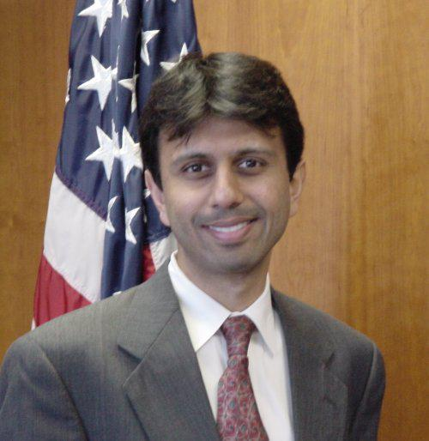  
*Jindal while working for the Department of Health and Human Services*

# Foster administration

* *Jindal was 24 at the time.*
* *Jindal was criticized during the 2007 campaign by the Louisiana AFL-CIO for closing some local clinics to reach that surplus.*
* *In 1999, at the request of the Louisiana governor's office and the Louisiana State Legislature, Jindal examined how Louisiana might use its $4.4 billion share of the tobacco settlement.*

In 1993, U.S. Representative Jim McCrery (whom Jindal had worked for as a summer intern) introduced him to Governor Mike Foster. In 1996, Foster appointed Jindal as Secretary of the Louisiana Department of Health and Hospitals, an agency that represented about 40 percent of the state budget and employed over 12,000 people. Foster called Jindal a genius who had a great deal of medical knowledge. Jindal was 24 at the time.

During his tenure, Louisiana's Medicaid program went from bankruptcy with a $400 million deficit into three years of surpluses totaling $220 million.

Jindal was criticized during the 2007 campaign by the Louisiana AFL-CIO for closing some local clinics to reach that surplus. Under Jindal's term, Louisiana nationally rose to third place in child healthcare screenings, with child immunizations rising, and introduced new and expanded services for the elderly and the disabled.

In 1998, Jindal was appointed executive director of the National Bipartisan Commission on the Future of Medicare, a 17-member panel charged with devising plans to reform Medicare. In 1999, at the request of the Louisiana governor's office and the Louisiana State Legislature, Jindal examined how Louisiana might use its $4.4 billion share of the tobacco settlement.[citation needed]

In 1998, Jindal received the Samuel S. Beard Award for greatest public service by an individual 35 years old or under, an award given annually by Jefferson Awards.

At 28 years of age in 1999, Jindal was appointed to become the youngest-ever president of the University of Louisiana System, the nation's 16th largest system of higher education with over 80,000 students.

# Bush administration

* *He resigned from that post on February 21, 2003, to return to Louisiana and run for governor.*

In March 2001, he was nominated by President George W. Bush to be Assistant Secretary of Health and Human Services for Planning and Evaluation. He was later unanimously confirmed by a vote of the United States Senate and began serving on July 9, 2001. In that position, he served as the principal policy adviser to the Secretary of Health and Human Services. He resigned from that post on February 21, 2003, to return to Louisiana and run for governor. He was assigned to help fight the nurse shortage by examining steps to improve nursing education.

# 2003 election for governor

* *Some political analysts blamed Jindal's loss for his refusal to answer questions targeted at his religion and ethnic background brought up in several Democratic advertisements, which the Jindal campaign called "negative attack ads."*
* *Jindal came to national prominence during the 2003 election for governor of Louisiana.*

Jindal came to national prominence during the 2003 election for governor of Louisiana. In what Louisianans call an "open primary" (but which is technically a nonpartisan blanket primary), Jindal finished first with 33 percent of the vote. He received endorsements from the largest paper in Louisiana, the Times-Picayune; the newly elected Democratic mayor of New Orleans, Ray Nagin; and the outgoing Republican governor, Mike Foster.

In the second balloting, Jindal faced the outgoing lieutenant governor, Kathleen Babineaux Blanco of Lafayette, a Democrat. Despite winning in Blanco's hometown, he lost many normally conservative parishes in north Louisiana, and Blanco prevailed with 52 percent of the popular vote.[citation needed]

Some political analysts blamed Jindal's loss for his refusal to answer questions targeted at his religion and ethnic background brought up in several Democratic advertisements, which the Jindal campaign called "negative attack ads." Despite losing the election in 2003, the run for governor made Jindal a well-known figure on the state's political scene and a rising star within the Republican Party.

# U.S. House of Representatives (2005–2008)

# Elections

# 2004

* *Jindal was only the second Indian-American to be elected to the United States Congress, after Dalip Singh Saund was elected in November 1955.*
* *A few weeks after the 2003 gubernatorial runoff, Jindal decided to run for Louisiana's 1st congressional district.*
* *Jindal's campaign was able to raise over $1 million very early in the campaign, making it harder for other candidates to effectively raise funds to oppose him.*

A few weeks after the 2003 gubernatorial runoff, Jindal decided to run for Louisiana's 1st congressional district. The incumbent, David Vitter, was running for the Senate seat being vacated by John Breaux. The Louisiana Republican Party endorsed him in the primary although Mike Rogers, also a Republican, was running for the same seat. The 1st District has been in Republican hands since a 1977 special election and is widely considered to be staunchly conservative. Jindal's campaign was able to raise over $1 million very early in the campaign, making it harder for other candidates to effectively raise funds to oppose him. He won the 2004 election with 78 percent of the vote.[citation needed]

Jindal was only the second Indian-American to be elected to the United States Congress, after Dalip Singh Saund was elected in November 1955.

# 2006

* *Jindal won re-election to a second term with 88% of the vote.*

Jindal won re-election to a second term with 88% of the vote.

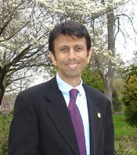  
*Jindal served as congressman for two terms until his election as governor*

# Congressional tenure

* *Jindal praised Bush's leadership on social security reform saying "The administration has a lot more work to do to continue educating the American people about the very serious challenges facing Social Security."*
* *In 2005, Jindal criticized Bush's budget for not calling for enough spending cuts.*
* *In response to Hurricane Katrina, Jindal stated "If we had been investing resources in restoring our coast, it wouldn't have prevented the storm, but the barrier islands would have absorbed some of the tidal surge."*

He was the second Indian American elected to Congress. He has reportedly lived in Kenner, Metairie, and Baton Rouge.

In 2005, Jindal criticized Bush's budget for not calling for enough spending cuts. He warned of the growth of Medicaid saying "Congress may act without them...there seems to be growing momentum that the status quo is not defensible." Jindal praised Bush's leadership on social security reform saying "The administration has a lot more work to do to continue educating the American people about the very serious challenges facing Social Security."

In response to Hurricane Katrina, Jindal stated "If we had been investing resources in restoring our coast, it wouldn't have prevented the storm, but the barrier islands would have absorbed some of the tidal surge."

# Committee assignments

* *Jindal served as president of the incoming freshman class of congressmen, in 2004.*

House Committee on Homeland Security

House Committee on Resources

House Committee on Education and the Workforce

He was made vice-chairman of the House Subcommittee on the Prevention of Nuclear and Biological Attacks. Jindal served as president of the incoming freshman class of congressmen, in 2004. He was elected to the position of House assistant majority whip, a senior leadership role. He served in this capacity from 2004 to 2006.

# 2007 election for governor

* *In the 2003 contest with Blanco, Jindal had lost most of the northern parishes.*
* *On January 22, 2007, Jindal announced his candidacy for governor.*
* *Jindal polled pluralities or majorities in 60 of the state's 64 parishes (equivalent to counties in other states).*
* *Jindal finished with 699,672 votes (54 percent).*

On January 22, 2007, Jindal announced his candidacy for governor. Polling data showed him with an early lead in the race, and he remained the favorite throughout the campaign. He defeated eleven opponents in the nonpartisan blanket primary held on October 20, including two prominent Democrats, State Senator Walter Boasso of Chalmette and Louisiana Public Service Commissioner Foster Campbell of Bossier City, and an independent, New Orleans businessman John Georges.

Jindal finished with 699,672 votes (54 percent). Boasso ran second with 226,364 votes (17 percent). Georges finished with 186,800 (14 percent), and Campbell, who is also a former state senator, ran fourth with 161,425 (12 percent). The remaining candidates collectively polled three percent of the vote. Jindal polled pluralities or majorities in 60 of the state's 64 parishes (equivalent to counties in other states). He lost narrowly to Georges in Orleans Parish, to Boasso in St. Bernard Parish (which Boasso represented in the Legislature), and in the two neighboring north Louisiana parishes of Red River and Bienville located south of Shreveport, both historically Democratic and supported Campbell. In the 2003 contest with Blanco, Jindal had lost most of the northern parishes. This marked the first time that a non-incumbent candidate for governor was elected without a runoff under the Louisiana election system.

# Governor of Louisiana (2008–2016)

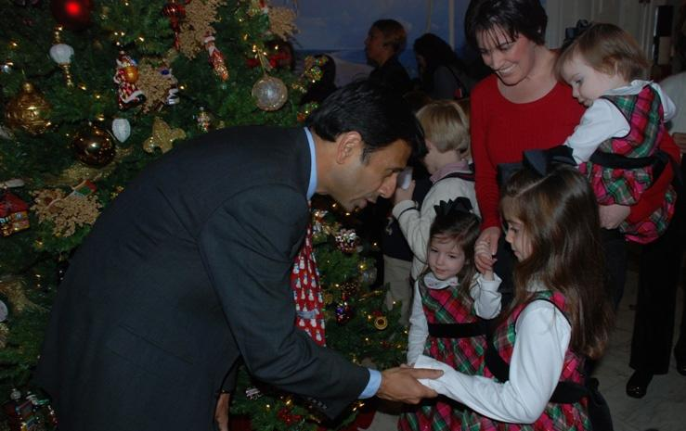  
*Governor Jindal greets children of deployed Louisiana National Guard Soldiers at the lighting of the State Capitol Christmas tree.*

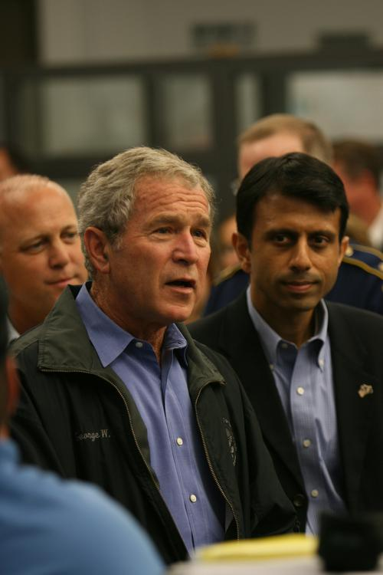  
*Then President George W. Bush and Jindal greeting EOC employees, during disaster recovery efforts for Hurricane Gustav, September 2008*

# First term

* *One of Jindal's first appointments was that of Mike Edmonson as superintendent of the Louisiana State Police.*
* *On June 27, 2008, Louisiana's Secretary of State confirmed that a recall petition had been filed against Jindal in response to Jindal's refusal to veto a bill that would have more than doubled the current state legislative pay.*

As governor-elect, Jindal named a new ethics team, with Democratic Shreveport businesswoman Virginia Kilpatrick Shehee, the first woman to have served in the state senate, as the vice chairman of the panel. Jindal assumed the position of governor when he took the oath of office on January 14, 2008. At thirty-six, he became the youngest sitting governor in the United States. He is also Louisiana's first non-white governor since P. B. S. Pinchback served for thirty-five days during Reconstruction, and the first non-white governor to be elected (Pinchback succeeded to the position of lieutenant governor on the death of Oscar Dunn, then to governor upon the impeachment of Henry Clay Warmoth). Additionally, Jindal became the first Indian American to be elected governor of any state in the United States.

In 2008, Jindal was ranked one of the nation's most popular governors with an approval rating of 77%.

One of Jindal's first appointments was that of Mike Edmonson as superintendent of the Louisiana State Police. Edmonson had been for twenty preceding years the bodyguard and confidant of LSU Tigers football coaches. Edmonson was also the deputy secretary of the Department of Public Safety, an agency with more than 2,900 employees and a budget of nearly $500 million.

In 2014, Jindal was compelled to urge repeal of a state law that he had earlier signed which provided enhanced retirement benefits to Edmonson and, inadvertently, to one other state trooper. Jindal said that he was unaware that the legislation, called in the media the "Edmonson Act," applied only to two persons. He urged the legislature to rewrite the law. Thereafter, Janice Clark, a state district court judge in Baton Rouge, declared that portion of the law enhancing the retirement benefits of Edmonson to be unconstitutional.

Another early appointee was that of former state representative Frank P. Simoneaux, a Baton Rouge attorney, as the chairman of the Louisiana Ethics Commission. Jimmy Faircloth, an attorney from Alexandria and Pineville, was the influential executive counsel from 2008 to 2009, when he stepped down to run unsuccessfully for the Louisiana Supreme Court. Faircloth was considered the legal architect of the special 2008 legislative session on ethics reform. He guided the Jindal administration through the aftermath of Hurricanes Gustav and Ike. After leaving the administration, he continued as a periodic legal advisor to Jindal.

On June 27, 2008, Louisiana's Secretary of State confirmed that a recall petition had been filed against Jindal in response to Jindal's refusal to veto a bill that would have more than doubled the current state legislative pay. During his gubernatorial campaign, Jindal had pledged to prevent legislative pay raises that would take effect during the current term.

Jindal responded by saying that he is opposed to the pay increase, but that he had pledged to let the legislature govern themselves.

On June 30, 2008, Jindal reversed his earlier position by vetoing the pay raise legislation, stating that he made a mistake by staying out of the pay raise issue. In response, the petitioners dropped their recall effort.

Standard and Poor's raised Louisiana's bond rating and credit outlook from stable to positive in 2009. In announcing this change, the organization gave credit to the state's strong management and "commitment to streamlining its government functions." Jindal met with President Barack Obama in October 2009 where the governor pushed for increased federal dollars to cover rising Medicaid costs, speeding the construction of hurricane-protection barriers, and financing the proposed Louisiana State University teaching hospital. During a town hall meeting, Obama praised Jindal as a "hard working man who is doing a good job" for the State, and expressed support for the governor's overhaul of the State's educational system in the area of increased charter schools.

Louisiana state government watchdog C.B. Forgotston, former counsel to the House Appropriations Committee who supported Jindal's election in 2007, has expressed disappointment with the governor in regard to the legislative pay raise and other fiscal issues. Forgotston said he would grade Jindal an A+ in public relations and a D in fiscal performance in office.

Jindal negotiated an agreement whereby Foster Farms, a private chicken processor, would receive $50 million in taxpayer funds to purchase a chicken processing plant owned by bankrupt Pilgrim's Pride.[citation needed]

Some claimed there is a conflict of interest in that Pilgrim's Pride founder Lonnie "Bo" Pilgrim contributed $2500 to Jindal's campaign in 2007. Other contributors to Jindal's campaign who benefited from economic development spending include Albemarle and Edison Chouest Offshore. Jindal however released a statement saying that this legislation saved over 1,000 jobs, serves as a stimulus to Louisiana's economy, and had wide bipartisan support.

# Hurricane Gustav

* *Jindal received bipartisan praise for his leadership during Gustav.*
* *Jindal oversaw one of the largest evacuations in U.S. history (nearly two million people) in late August 2008 prior to the Louisiana landfall of Hurricane Gustav.*
* *Jindal had been scheduled to address the Republican National Convention, but cancelled his plans in order to focus on Louisiana's needs during the storm.*

Jindal oversaw one of the largest evacuations in U.S. history (nearly two million people) in late August 2008 prior to the Louisiana landfall of Hurricane Gustav. He issued mandatory evacuation orders for the state's coastal areas and activated 3,000 National Guardsman to aid in the exodus. He also ordered the state to purchase generators to provide needed power to hospitals and nursing homes without power. Government officials vacated hospitals and nursing homes and put the poor, the ill, and the elderly on buses and trains out of town. The evacuation was credited as one reason that Gustav resulted in only 16 deaths in the U.S. The state's successful response to Hurricane Gustav was in stark contrast to the failed hurricane response system for Hurricane Katrina in 2005. Jindal received bipartisan praise for his leadership during Gustav. Jindal had been scheduled to address the Republican National Convention, but cancelled his plans in order to focus on Louisiana's needs during the storm.

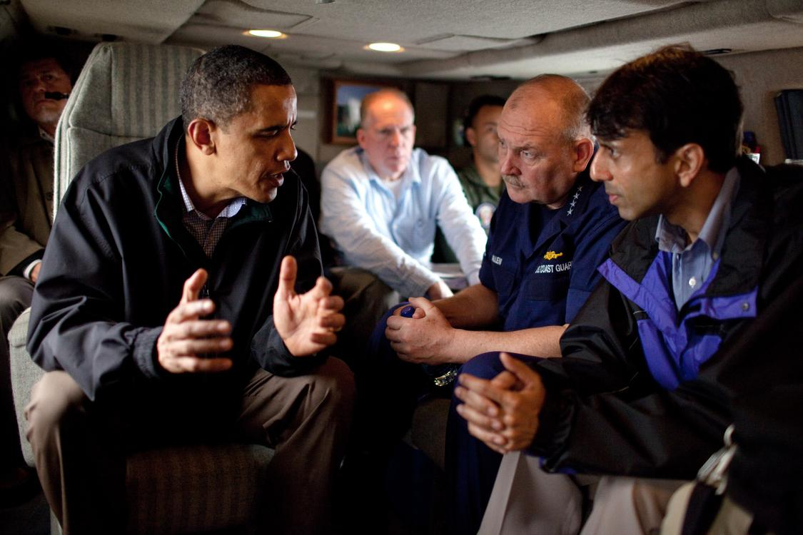  
*U.S. President Barack Obama talks with Louisiana Governor Bobby Jindal and U.S. Coast Guard Commandant Admiral Thad Allen in May 2010.*

# 2011 re-election campaign

* *Running against four Democrats, a Libertarian and four independents in the jungle primary, Jindal received 66% of the vote in the blanket primary, thereby winning election in the first round.*
* *Jindal announced his intention to seek reelection in 2011.*

Jindal announced his intention to seek reelection in 2011. With high approval ratings and excessive amounts of campaign funds, Democrats struggled to land a recruit of any substance. Running against four Democrats, a Libertarian and four independents in the jungle primary, Jindal received 66% of the vote in the blanket primary, thereby winning election in the first round.

# Second term

* *On October 25, 2011, in preparing for his second term, Jindal tapped Republican state representative Chuck Kleckley of Lake Charles and State Senator John Alario of Westwego as his choices for Speaker of the Louisiana House of Representatives and Louisiana Senate President, respectively.*
* *In August 2012, Jindal declared a statewide state of emergency due to the threat of subsidence and subsurface instability that threatens the lives and property of the citizens of the state.*

In August 2011, the American Legislative Exchange Council (ALEC) awarded Jindal the Thomas Jefferson Freedom Award for "outstanding public service".[unreliable source?]

On October 25, 2011, in preparing for his second term, Jindal tapped Republican state representative Chuck Kleckley of Lake Charles and State Senator John Alario of Westwego as his choices for Speaker of the Louisiana House of Representatives and Louisiana Senate President, respectively. Lawmakers routinely approved the governor's choices for the two leadership positions. Alario is a long-term Democrat who switched parties prior to the 2011 elections. Jindal in January 2012 elevated John C. White, the short-term superintendent at the Recovery School District in New Orleans, to the position of state superintendent of education.

In August 2012, Jindal declared a statewide state of emergency due to the threat of subsidence and subsurface instability that threatens the lives and property of the citizens of the state.

By the end of Jindal's second term, he saw a marked drop in his state popularity and problems such as a budget deficit and cuts to public expenditure. He could not stand for a third term because the governor of Louisiana is subject to term limits.

# Tax system proposals

* *Forgotston correctly predicted that Jindal's plan would fail to clear the legislature because of the higher sales taxes, the lack of needed support from Democrats, and the likelihood that the plan would not increase overall state revenues.*
* *In January 2013, Jindal released a plan that would eliminate the Louisiana state income tax, which he felt would expand business investment in the state, and then raise sales taxes in order to keep the plan revenue-neutral.*

In January 2013, Jindal released a plan that would eliminate the Louisiana state income tax, which he felt would expand business investment in the state, and then raise sales taxes in order to keep the plan revenue-neutral. Self-styled taxpayer watchdog and former legislative aide C.B. Forgotston correctly predicted that Jindal's plan would fail to clear the legislature because of the higher sales taxes, the lack of needed support from Democrats, and the likelihood that the plan would not increase overall state revenues.

On April 8, 2013, the first day of the legislative session, Jindal dropped the plan after acknowledging some negative response to the plan from legislators and the public, but said he would still like the legislature to formulate its own plan that could end the state income tax.

# Energy plan

* *Jindal announced, in September 2014, a six-point energy platform that would, among other things, open up energy production on federal land and eliminated proposed carbon restrictions.*

Jindal announced, in September 2014, a six-point energy platform that would, among other things, open up energy production on federal land and eliminated proposed carbon restrictions.

# National politics

# Speculation about 2008 vice presidential nomination

* *Heightening the speculation, McCain invited Jindal, Gov.*
* *On February 8, 2008, conservative radio host Rush Limbaugh mentioned on his syndicated show that Jindal could be a possible choice for the Republican vice presidential nomination in 2008.*
* *However, on July 23, 2008, Jindal said that he would not be the Republican vice presidential nominee in 2008.*
* *While Jindal was given a prime-time speech slot at the party convention, he was not offered the keynote speech.*

On February 8, 2008, conservative radio host Rush Limbaugh mentioned on his syndicated show that Jindal could be a possible choice for the Republican vice presidential nomination in 2008. He said that Jindal might be perceived as an asset to John McCain's campaign because he has wide support in the conservative and moderate wings of the Republican Party and his immigrant past offsets McCain's white heritage. If McCain had won the presidency, he would have been the oldest president ever inaugurated to a first term. Heightening the speculation, McCain invited Jindal, Gov. Charlie Crist of Florida, Gov. Tim Pawlenty of Minnesota and McCain's former rivals Mitt Romney and Mike Huckabee to meet at McCain's home in Arizona on May 23, 2008, according to a Republican familiar with the decision; Romney, Huckabee, and Pawlenty, all of whom were already well acquainted with McCain, declined because of prior commitments. The meeting may have served a different purpose, such as consideration of Jindal for the opportunity to speak at the 2008 Republican National Convention, in a similar fashion to Barack Obama at the 2004 Democratic National Convention, cementing a place for him in the party and opening the gate for a future run for the presidency. Speculation was fueled by simultaneous July 21, 2008, reports that McCain was making a sudden visit to Louisiana to confer again with Jindal and that McCain was readying to name his running mate within a week. However, on July 23, 2008, Jindal said that he would not be the Republican vice presidential nominee in 2008. Jindal added that he "never talked to the senator [McCain] about the vice presidency or his thoughts on selecting the vice president." Ultimately, on August 29, 2008, McCain chose then-Gov. Sarah Palin of Alaska as his running mate. While Jindal was given a prime-time speech slot at the party convention, he was not offered the keynote speech. During the presidential campaign, Jindal expressed admiration for both Senators McCain and Obama, and maintained that both have made positive contributions to the nation.

# Republican response to President Obama's address to Congress

* *Referring to Jindal as "devoid of substantive ideas for governing the country", political commentator Rachel Maddow summarized Jindal's Katrina remark as follows: "[Jindal states that] since government failed during Hurricane Katrina, we should understand, not that government should not be allowed to fail again, but that government...never works.*
* *Jindal's story of meeting Lee in the immediate aftermath of Hurricane Katrina was questioned following the speech, as Jindal was not in New Orleans at the time.*

On February 24, 2009, Jindal delivered the official Republican response to President Obama's address to a joint session of Congress. Jindal called the president's economic stimulus plan "irresponsible" and argued against government intervention. He used Hurricane Katrina to warn against government solutions to the economic crisis. "Today in Washington, some are promising that government will rescue us from the economic storms raging all around us," Jindal said. "Those of us who lived through Hurricane Katrina, we have our doubts." He praised the late sheriff Harry Lee for standing up to the government during Katrina. The speech met with biting reviews from some members of both the Democratic and the Republican parties. Referring to Jindal as "devoid of substantive ideas for governing the country", political commentator Rachel Maddow summarized Jindal's Katrina remark as follows: "[Jindal states that] since government failed during Hurricane Katrina, we should understand, not that government should not be allowed to fail again, but that government...never works. That government can't work, and therefore we should stop seeking a functioning government." David Johnson, a Republican political strategist criticized Jindal's mention of Hurricane Katrina, stating "The one thing Republicans want to forget is Katrina." While Jindal's speech was poorly received by several Democratic and Republican critics, others argued that the speech should be judged on substance rather than delivery style.

Jindal's story of meeting Lee in the immediate aftermath of Hurricane Katrina was questioned following the speech, as Jindal was not in New Orleans at the time.

On February 27, 2009, a spokesman for Jindal clarified the timing of the meeting, stating that the story took place days after the storm. The opportunity to give the response to President Obama's speech was compared by some commentators to winning "second prize in a beauty contest", a reference to the board game Monopoly.

# 2012 presidential election

* *Jindal has stated that he has no involvement with the PAC.*
* *Jindal had been mentioned as a potential candidate for the 2012 presidential election.*
* *After the defeat of Romney-Ryan, Jindal called for his party to return to "the basics...*
* *In 2012, Jindal traveled across the country in support of the Mitt Romney-Paul Ryan ticket.*

Jindal had been mentioned as a potential candidate for the 2012 presidential election. On December 10, 2008, Jindal indicated that he would likely not run for president in 2012, saying he will focus on his re-election in 2011 and that this would make transitioning to a national campaign difficult, though he did not rule out a possible 2012 presidential bid.  
Speculation increased when Republicans chose Jindal to deliver the response to President Obama's first address to a joint session of Congress.

The Jindal for President Draft Council Inc. PAC was formed in 2009 to raise funds for a future presidential run. Jindal has stated that he has no involvement with the PAC.

In April 2010, while speaking at the Southern Republican Leadership Conference, Jindal ruled out running for the Republican nomination for President in 2012.

In 2012, Jindal traveled across the country in support of the Mitt Romney-Paul Ryan ticket. Because Louisiana and other Deep South states voted heavily for the GOP, Jindal could hence devote his campaign time elsewhere. In August 2012, Politico reported that "Bobby Jindal would be considered [for] and would likely take" appointment as United States Secretary of Health and Human Services in a potential Romney cabinet.

After the defeat of Romney-Ryan, Jindal called for his party to return to "the basics... If we want people to like us, we have to like them first," he said on the interview program Fox News Sunday. As the incoming president of the Republican Governors Association, which had thirty members in 2013, Jindal questioned Romney for having criticized President Obama as having provided "extraordinary financial gifts from the government". In reply to Romney, Jindal said, "You don't start to like people by insulting them and saying their votes were bought." Jindal said that his party must convince a majority of voters that it supports the middle class and the principle of upward mobility. He also criticized what he termed "stupid" remarks regarding rape and conception made in 2012 by defeated Republican U.S. Senate nominees Todd Akin in Missouri and Richard Mourdock in Indiana.

# 2016 presidential candidacy

* *In 2013, with polls showing Jindal's approval ratings in Louisiana falling significantly, some analysts wrote off Jindal as a serious national contender, though others pointed to Romney as an example of someone who still won the Presidential nomination despite poor approval ratings from his home state.*
* *As of early September, Jindal was polling at 1 percent among the Republican primary electorate.*

In November 2012, after the election, Jindal was featured in a Time magazine article titled "2016: Let's Get The Party Started", where he was listed as a possible Republican candidate for the presidency in 2016. The article cited his fiscal and social conservative policies and his Indian American background, which would bring diversity to the GOP.

In 2013, with polls showing Jindal's approval ratings in Louisiana falling significantly, some analysts wrote off Jindal as a serious national contender, though others pointed to Romney as an example of someone who still won the Presidential nomination despite poor approval ratings from his home state.

In October 2013, Jindal told Fox News Sunday that he was still mulling a 2016 presidential run.

On May 18, 2015, Jindal formed a presidential exploratory committee to determine whether he would run as a candidate in the 2016 presidential election, and he announced his candidacy on June 24.

As of early September, Jindal was polling at 1 percent among the Republican primary electorate. On November 17, 2015, Jindal appeared on Special Report with Bret Baier on the Fox News Channel, announcing that he was ending his run for president, saying "I've come to the realization that this is not my time."

During his campaign, Jindal called Donald Trump a "narcissist" and an "egomaniacal madman", but afterward said that he would support Trump because "electing Donald Trump would be the second-worst thing we could do this November, better only than electing Hillary Clinton to serve as the third term for the Obama administration's radical policies."

# Political positions

# Abortion and stem cell research

* *In 2003, Jindal stated that he did not object to the use of emergency contraception in the case of rape if the victim requests it.*
* *Jindal has a 100% pro-life voting record according to the National Right to Life Committee.*

Jindal has a 100% pro-life voting record according to the National Right to Life Committee. He opposes abortion in general, but does not condemn medical procedures aimed at saving the life of the mother that indirectly result in the loss of the unborn child, such as salpingectomy for an ectopic pregnancy.

In 2003, Jindal stated that he did not object to the use of emergency contraception in the case of rape if the victim requests it. While in the House of Representatives, he supported two bills to prohibit transporting minors across state lines to obtain an abortion; the bills aimed to prevent doctors and others from helping a minor avoid parental notification laws in their home state by procuring an abortion in another state. He opposed and voted against expanding public funding of embryonic stem cell research.

# Same-sex marriage

* *Jindal opposed the legalization of same-sex marriage.*
* *In Louisiana, we will opt for traditional marriage.*
* *In December 2008, Jindal announced the formation of the Louisiana Commission on Marriage and Family,*

Jindal opposed the legalization of same-sex marriage. In Congress, he voted for the Federal Marriage Amendment to restrict marriage to a union between one man and one woman. He also voted against the Local Law Enforcement Hate Crimes Prevention Act of 2007. In December 2008, Jindal announced the formation of the Louisiana Commission on Marriage and Family,

Following the 2013 Supreme Court's rulings on DOMA and Proposition 8, he said: "I believe every child deserves a mom and a dad. This opinion leaves the matter of marriage to the states where people can decide. In Louisiana, we will opt for traditional marriage. How about we let the people decide for themselves, via their representatives and via referendum?"

# Marriage and Conscience Act

* *Jindal responded by issuing Executive Order BJ-2015-8, (the "Marriage and Conscience Order"), which attempted to achieve the goals of the failed legislation.*
* *In April 2015, Jindal announced that he would sign into law the Louisiana Marriage and Conscience Act proposed by newly elected Republican state representative Mike Johnson.*

In April 2015, Jindal announced that he would sign into law the Louisiana Marriage and Conscience Act proposed by newly elected Republican state representative Mike Johnson. In a guest editorial in The New York Times, Jindal said that he has been contacted by several corporations who oppose the bill: "They are free to voice their opinions, but they will not deter me." Johnson's bill proposed to bar the state from revoking licenses or refusing to engage in contract with individuals or businesses because they oppose marriage between two persons of the same sex. Johnson's bill was meant to guarantee the tax status of groups that support only traditional marriage. In May 2015, the legislature killed the measure. Four Republican members, Pete Huval of Breaux Bridge, Gregory A. Miller of Norco, Clay Schexnayder of Gonzales, and Nancy Landry of Lafayette, joined Democrats in killing the bill. Jindal responded by issuing Executive Order BJ-2015-8, (the "Marriage and Conscience Order"), which attempted to achieve the goals of the failed legislation. Johnson said he intended to re-introduce the measure in 2016.

# Government ethics

* *However, the Louisiana governor's office was ranked last for transparency in the United States both prior, and subsequent, to Jindal's election, as reported by the WDSU I-Team.*
* *At least two legislators, state representatives Walker Hines and Neil Abramson, argued that this may be attributed to legislation that removed the governor's records from the public domain; they argued that the legislation was surreptitiously inserted as a last-minute amendment into an education bill by Jindal's office on the last day of the 2008 session, providing no time to properly review it before it passed the legislature and was signed into law by Jindal.*

He vetoed state legislation to increase pay for state legislators. However, the Louisiana governor's office was ranked last for transparency in the United States both prior, and subsequent, to Jindal's election, as reported by the WDSU I-Team. At least two legislators, state representatives Walker Hines and Neil Abramson, argued that this may be attributed to legislation that removed the governor's records from the public domain; they argued that the legislation was surreptitiously inserted as a last-minute amendment into an education bill by Jindal's office on the last day of the 2008 session, providing no time to properly review it before it passed the legislature and was signed into law by Jindal.

In 2014, Jindal signed into law a bill sponsored by Democratic state representative Jeff Arnold of New Orleans to permit Francis C. Heitmeier, a Democratic former member of both houses of the Louisiana Legislature and an unsuccessful 2006 candidate for Louisiana Secretary of State, to lobby legislators even though Heitmeier's brother, David Heitmeier, was, at the time, the sitting senator for District 7, which includes the Algiers neighbourhood of New Orleans. The special exemption permitted an immediate family member of an elected official who was a lobbyist for the executive branch of state government for the year prior to 9 January 2012, to be able to lobby the legislature. David Heitmeier abstained from voting on the measure which was written with the intent of benefiting Francis Heitmeier.

# Gun rights and gun control

* *Jindal earned an A rating from Gun Owners of America while he was in Congress.*
* *Jindal stated his support of the Second Amendment's right to bear arms.*
* *In July 2015, during an interview with CBS, Jindal stated that he supported stricter background checks, and that every state should begin to enact tougher background checks on gun buyers.*

Jindal stated his support of the Second Amendment's right to bear arms. He opposed efforts to restrict gun rights and received an endorsement from the National Rifle Association. Jindal earned an A rating from Gun Owners of America while he was in Congress.

As a Congressman, he sponsored the Disaster Recovery Personal Protection Act of 2006 with Senator Vitter.

In July 2015, during an interview with CBS, Jindal stated that he supported stricter background checks, and that every state should begin to enact tougher background checks on gun buyers. He hunts.

# Tax policy

* *In January 2013, Jindal said he wanted to eliminate all Louisiana corporate and personal income taxes, without giving details for his proposal.*
* *As Governor of Louisiana, Jindal received grades of A in 2010, B in 2012, and B in 2014 from the Cato Institute, a libertarian think tank, in their biennial Fiscal Policy Report Card on America's Governors.*

As a private citizen, Jindal voted in 2002 for the Louisiana constitutional amendment known as the Stelly Plan which lowered some sales taxes in exchange for higher income taxes. After taking office, Jindal cut taxes a total of six times, including the largest income tax cut in Louisiana's history – a cut of $1.1 billion over five years, along with accelerating the elimination of the tax on business investments. In January 2013, Jindal said he wanted to eliminate all Louisiana corporate and personal income taxes, without giving details for his proposal.

As U.S. Representative from Louisiana, Jindal received grades of B in 2005, B- in 2006, and C in 2007 from the National Taxpayers Union, a conservative taxpayers advocacy organization. As Governor of Louisiana, Jindal received grades of A in 2010, B in 2012, and B in 2014 from the Cato Institute, a libertarian think tank, in their biennial Fiscal Policy Report Card on America's Governors.

# Education

* *Jindal said he believed that every child learns differently.*
* *In 2015, Jindal said that investments in technology would render Common Core obsolete.*
* *Many participants circulated petitions to recall Jindal and Republican House Speaker Chuck Kleckley.*
* *In 2008, Jindal came out in favour of the Common Core State Standards Initiative, which Louisiana adopted in 2010.*

In 2008, Jindal came out in favour of the Common Core State Standards Initiative, which Louisiana adopted in 2010.

In 2014, Jindal wrote that "It has become fashionable in the news media to believe there is a right-wing conspiracy against Common Core."

In 2015, Jindal said that investments in technology would render Common Core obsolete.

Jindal proposed budgets that impose cuts on higher education funding in Louisiana, leading to protests from students and education advocates. Jindal proposed several controversial education reforms, including vouchers for low income students in public schools to attend private institutions using Minimum Foundation Program funds.

The legislation also included controversial changes in teacher evaluations, tenure and pensions. Hundreds of teachers, administrators and public education supporters protested against the legislation at the capital of Louisiana, some of whom cancelled classes to attend demonstrations. Many participants circulated petitions to recall Jindal and Republican House Speaker Chuck Kleckley. In April 2012, a Louisiana Public Broadcasting program examined possible conflicts between aspects of the Jindal education reform plan and the federal desegregation orders still in place in many parts of Louisiana.

Jindal said he believed that every child learns differently. For him, some will accomplish great things in a public school while some will learn better in an online program, and still others will make waves in charter schools, or in parochial schools and dual-enrollment programmes. However, in all these choices, the parents must be trusted to make the best decisions for their children.

# Evolution

* *Jindal signed a law that permitted teachers at public schools to supplement standard evolutionary curricula with analysis and critiques that may include intelligent design.*
* *and some genetics professors at Brown University, Jindal signed the Louisiana Academic Freedom Act which passed with a vote of 94–3 in the State House and 35–0 in the State Senate in 2008.*

Jindal signed a law that permitted teachers at public schools to supplement standard evolutionary curricula with analysis and critiques that may include intelligent design. The law forbids "the promotion of any religious doctrine and will not discriminate against religion or non-religion". Louisiana ACLU Director Marjorie Esman said that if the act was utilized as written, it would be on firm constitutional footing, stating that the Act is "susceptible to a constitutional challenge." Despite calls for a veto from John Derbyshire [who?] and some genetics professors at Brown University, Jindal signed the Louisiana Academic Freedom Act which passed with a vote of 94–3 in the State House and 35–0 in the State Senate in 2008.[citation needed]

The Society for Integrative and Comparative Biology rejected New Orleans as a site for their 2010 meeting and the American Society for Biochemistry and Molecular Biology will not conduct future meetings in Louisiana.

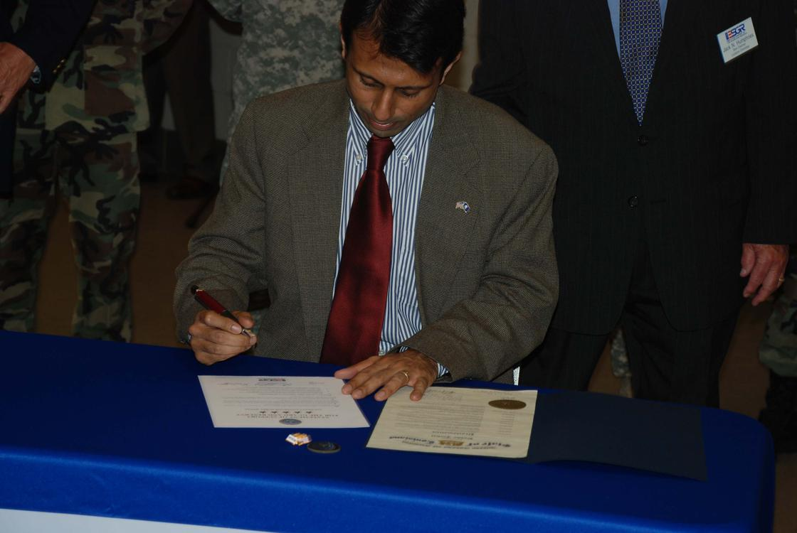  
*Gov. Bobby Jindal signs a Five-Star Statement of Support for Employer Support of the Guard and Reserve at Camp Beauregard on October 14, 2008. The document signing was an opportunity to join employers from across the country in supporting Soldiers*

# Civil liberties

* *Jindal opposed the Fairness Doctrine believing it to be a violation of the Constitution's guarantee of free speech and vowed protection of property rights.*
* *In the 2009 legislative session, Jindal expressed support for a bill by state representative James H. "Jim" Morris of Oil City, which would permit motorcyclists to choose whether or not to wear a helmet.*

Jindal opposed the Fairness Doctrine believing it to be a violation of the Constitution's guarantee of free speech and vowed protection of property rights. Jindal voted to extend the Patriot Act, voted in favour of the Military Commissions Act of 2006, supported a constitutional amendment banning flag burning, and voted for the Real ID Act of 2005.

In the 2009 legislative session, Jindal expressed support for a bill by state representative James H. "Jim" Morris of Oil City, which would permit motorcyclists to choose whether or not to wear a helmet. Morris' bill easily passed the House but was blocked in the  
Senate Health Committee.

# Immigration laws

* *He voted to build a fence along the Mexican border and opposed granting amnesty for illegal immigrants.*
* *He criticized illegal immigration as a drain on the economy, as well as being unfair to those who entered the country by legal means.*

He criticized illegal immigration as a drain on the economy, as well as being unfair to those who entered the country by legal means. He voted to build a fence along the Mexican border and opposed granting amnesty for illegal immigrants.

# Health care

* *Jindal supported co-payments in Medicaid.*
* *In collaboration with Health Secretary Alan Levine, Jindal drafted the Louisiana Health First Initiative.*
* *During Jindal tenure, over 11,000 uninsured children were added to the State's Children's Health Insurance Program.*

Jindal refused to accept federal funds to expand Medicaid after the passage of the Affordable Care Act, costing his state $1.65 billion in federal health-care assistance for the poor. He supported increased health insurance portability; laws promoting coverage of pre-existing medical conditions; a cap on malpractice lawsuits; an easing of restrictions on importation of prescription medications; the implementation of a streamlined electronic medical records system; an emphasis on preventative care rather than emergency room care; and tax benefits aimed at making health insurance more affordable for the uninsured and targeted to promote universal access. During Jindal tenure, over 11,000 uninsured children were added to the State's Children's Health Insurance Program. He also opposed a federal government-run, single-payer system, but supported state efforts to reduce the uninsured population. He has also supported expanding services for autistic children, and promoted a national childhood cancer database. In collaboration with Health Secretary Alan Levine, Jindal drafted the Louisiana Health First Initiative. This plan focused on expanding health insurance coverage for the state's indigent population, increasing Medicaid choice, reducing fraud, authorizing funding of a new charity hospital, and increasing transparency in Medicaid by making performance measures available over the internet. Jindal supported co-payments in Medicaid. Due to a congressional reduction in federal Medicaid financing rates, the Jindal administration chose to levy the largest slice of cuts on the network of LSU charity hospitals and clinics, requiring some facilities to close.

# Environmental issues and offshore drilling

* *In September 2014, Jindal stated that global warming was more about increasing government regulation, and released an energy plan that was critical of the Obama Administration's policies.*
* *Jindal has pledged state support for the development of economically friendly cars in northeastern Louisiana in conjunction with alternative energy advocate T. Boone Pickens.*

Jindal issued an executive order increasing office recycling programs, reducing solid waste and promoting paperless practices, offering tax credit for hybrid fuel vehicles, increasing average fuel economy goals by 2010, as well as increasing energy efficiency goals and standards for the state. He has stated his opposition to and voted for the criminalization of oil cartels such as OPEC. As a representative in the House, he supported a $300-million bill to fund Louisiana coastal restoration. In addition, he was the chief sponsor of successful legislation to expand the Jean Lafitte National Historical Park by over 3,000 acres (12 km2). Jindal signed bill SB 469 that would limit actions aimed at oil and gas companies operating along the coast. Jindal has pledged state support for the development of economically friendly cars in northeastern Louisiana in conjunction with alternative energy advocate T. Boone Pickens. In September 2014, Jindal stated that global warming was more about increasing government regulation, and released an energy plan that was critical of the Obama Administration's policies.

# Earmarks

* *Jindal vetoed over 250 earmarks in the 2008 state budget, twice the total number of such vetoes by previous governors in the preceding 12 years.*
* *In 2007, Jindal led the Louisiana House delegation and ranked 14th among House members in requested earmark funding at nearly $97 million (however in over 99% of these requests, Jindal was a co-sponsor and not the primary initiator of the earmark legislation).*

In 2007, Jindal led the Louisiana House delegation and ranked 14th among House members in requested earmark funding at nearly $97 million (however in over 99% of these requests, Jindal was a co-sponsor and not the primary initiator of the earmark legislation). $5 million of Jindal's earmark requests were for state defense and indigent healthcare related expenditures, another $50 million was for increasing the safety of Louisiana's waterways and levees after breaches following Hurricane Katrina, and the remainder was targeted towards coastal restoration and alternative energy research. As governor, in 2008, Jindal used his line item veto to strike $16 million in earmarks from the state budget but declined to veto $30 million in legislator-added spending. Jindal vetoed over 250 earmarks in the 2008 state budget, twice the total number of such vetoes by previous governors in the preceding 12 years.

# Opposition to Recovery Act

* *Jindal intends to accept at least $2.4 billion from the stimulus package.*
* *Jindal has been an opponent of the American Recovery and Reinvestment Act of 2009.*
* *Citing concerns that the augmentation of unemployment insurance may obligate the state to raise taxes on businesses, Jindal had indicated his intention to forgo federal stimulus plan funds ($98 million) aimed at increasing unemployment insurance for Louisiana.*

Jindal has been an opponent of the American Recovery and Reinvestment Act of 2009. Citing concerns that the augmentation of unemployment insurance may obligate the state to raise taxes on businesses, Jindal had indicated his intention to forgo federal stimulus plan funds ($98 million) aimed at increasing unemployment insurance for Louisiana. Louisiana has since been obligated to raise taxes on businesses because the unemployment trust fund had dropped below the prescribed threshold. Louisiana was set to receive about $3.8 billion overall. Jindal intends to accept at least $2.4 billion from the stimulus package. He called parts of the plan "irresponsible", saying that "the way to lead is not to raise taxes and put more money and power in hands of Washington politicians."

# No-go zones

* *In 2015, Jindal travelled to the UK to speak out against so-called "no-go zones" that are in London and other western cities.*
* *When later asked by CNN to provide specific examples, Jindal declined.*
* *Jindal later confirmed his meaning "I knew that by speaking the truth we were going to make people upset."*

In 2015, Jindal travelled to the UK to speak out against so-called "no-go zones" that are in London and other western cities. British Prime Minister David Cameron had earlier stated that there were not any no-go zones in the UK. Jindal later confirmed his meaning "I knew that by speaking the truth we were going to make people upset." When later asked by CNN to provide specific examples, Jindal declined. He later added that some Muslim immigrants are trying to "colonize" cities in Europe and "overtake the culture", and that it could happen next in the U.S.

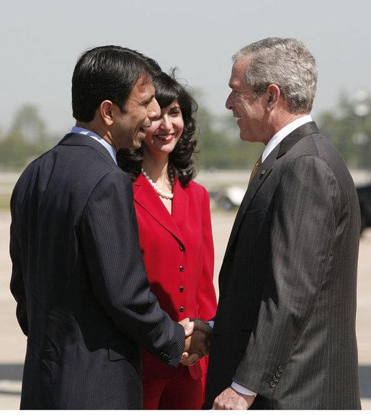  
*Bobby and Supriya Jolly Jindal meet with then-President George W. Bush.*

# Personal life

* *Before Jindal was born, his father Amar Jindal was assistant professor of engineering at Punjab University in Chandigarh.*
* *Jindal was raised in a Hindu household.*
* *Jindal's father went on to work with a Louisiana railroad company, and his mother transitioned into IT.*
* *Jindal enjoys hunting in Louisiana.*

Jindal was raised in a Hindu household. He is of Indian descent and is a U.S. citizen by birthright. He converted to Christianity while in Baton Rouge Magnet High School. During his first year at Brown University, he was baptized into the Roman Catholic Church as an adult under the Rite of Christian Initiation of Adults (RCIA). His family attends weekly Mass at Saint Aloysius Parish in Baton Rouge.

Before Jindal was born, his father Amar Jindal was assistant professor of engineering at Punjab University in Chandigarh. After settling into Louisiana, both elder Jindals transitioned into new fields. Jindal's father went on to work with a Louisiana railroad company, and his mother transitioned into IT. Jindal's mother, Raj Jindal, serves now as information technology director for the Louisiana Workforce Commission (formerly the Louisiana Department of Labor) and served as Assistant Secretary to former State Labor Secretary Garey Forster during the administration of Gov. Mike Foster Jindal has a younger brother, Nikesh, who is a registered Republican and supported his brother's campaign for governor. Nikesh went to Dartmouth College, where he graduated with honors, and then Yale Law School. Nikesh is now a lawyer in Washington, D.C.

Jindal's nickname dates to his childhood identification with Bobby Brady, a character from the 1970s sitcom The Brady Bunch. He has been known by his nickname ever since, although his legal name remains Piyush Jindal.

In 1997, Jindal married Supriya Jolly, who was born in New Delhi, India and moved to Baton Rouge with her parents when she was four years old. The two attended the same high school, but Supriya's family moved from Baton Rouge to New Orleans after her freshman year. They did not begin dating until much later when Jindal invited her to a Mardi Gras party after another friend had canceled. Supriya Jindal earned a bachelor's degree in chemical engineering and an M.B.A. degree from Tulane University. She is working on a PhD in marketing at Louisiana State University. She created The Supriya Jindal Foundation for Louisiana's Children, a non-profit organization aimed at improving math and science education in grade schools.

They have three children: Selia Elizabeth, Shaan Robert, and Slade Ryan. Shaan was born with a congenital heart defect and had surgery as an infant. The Jindals have been outspoken advocates for children with congenital defects, particularly those without insurance. In 2006, he and his wife delivered their third child at home, with him receiving medical coaching by phone to deliver their boy.

Jindal enjoys hunting in Louisiana.

# Writings

* *However, Jindal questioned whether what he saw was actually an example of "spiritual warfare".*
* *A list of Jindal's published writings up to 2001 can be found in the hearing report for his 2001 U.S. Senate confirmation.*
* *Jindal's pre-2001 writings include several articles in the New Oxford Review, one of which later made news during his 2003 gubernatorial race.*

A list of Jindal's published writings up to 2001 can be found in the hearing report for his 2001 U.S. Senate confirmation. They include newspaper columns, law review articles, and first authorships in several scientific and policy articles that have appeared in the prominent Journal of the American Medical Association, Journal of the Louisiana State Medical Association, and Hospital Outlook.

Jindal's pre-2001 writings include several articles in the New Oxford Review, one of which later made news during his 2003 gubernatorial race. In that 1994 article titled "Physical Dimensions of Spiritual Warfare", Jindal described the events leading up to an apparent exorcism of a friend and how he felt unable to help her at the time. However, Jindal questioned whether what he saw was actually an example of "spiritual warfare".

In November 2010, Jindal published the book Leadership and Crisis, a semi-autobiography significantly influenced by his experiences with the most recent Gulf Oil Spill caused by the Deepwater Horizon explosion.

# Post-Politics

* *In 2017, Jindal took a position as an operating adviser for Ares Management, a global investment firm based in Los Angeles.*

In 2017, Jindal took a position as an operating adviser for Ares Management, a global investment firm based in Los Angeles.

# Electoral history

* *Governor of Louisiana, 2007*
* *Governor of Louisiana, 2011*
* *Governor of Louisiana, 2003*

Governor of Louisiana, 2003

Threshold > 50%

First Ballot, October 4, 2003

Second Ballot, November 15, 2003

U.S. Representative, 1st Congressional District, 2004

Threshold > 50%

First Ballot, November 2, 2004

U.S. Representative, 1st Congressional District, 2006

Threshold > 50%

First Ballot, November 7, 2006

Governor of Louisiana, 2007

Threshold > 50%

First Ballot, October 20, 2007

Governor of Louisiana, 2011

Threshold > 50%

First Ballot, October 22, 2011

# See also

* *Republican Party presidential candidates, 2016*

List of Asian Americans and Pacific Islands Americans in the United States Congress

Republican Party presidential candidates, 2016

# Videos

* *(3) Final State of the State Address from April 13, 2015*
* *(1) Jindal's Inauguration as Louisiana's 55th Governor from January 14, 2008*

(1) Jindal's Inauguration as Louisiana's 55th Governor from January 14, 2008

(2) Second inauguration from January 9, 2012

(3) Final State of the State Address from April 13, 2015

# References

# External links

* *Bobby Jindal: “I Am Running for President” (Full Transcript)*
* *Bobby Jindal at Curlie*
* *Bobby Jindal for governor*

Bobby Jindal for governor

Bobby Jindal at Curlie

Appearances on C-SPAN

Bobby Jindal: “I Am Running for President” (Full Transcript)

Biography at the Biographical Directory of the United States Congress

Financial information (federal office) at the Federal Election Commission